4.2 Polynomial Functions and Models

Polynomial Functions

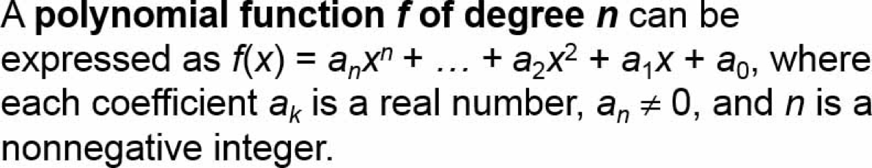

Question: What is the degree of k(x)? What is the leading coefficient?
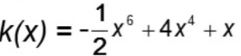

Degree = 6
Leading coefficient = -1/2

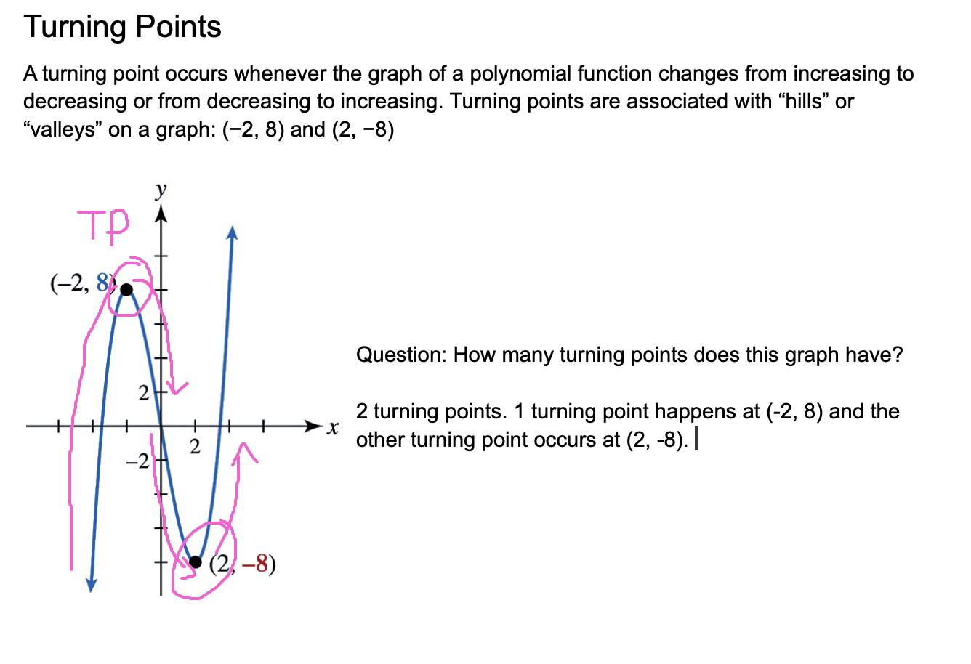

End Behavior

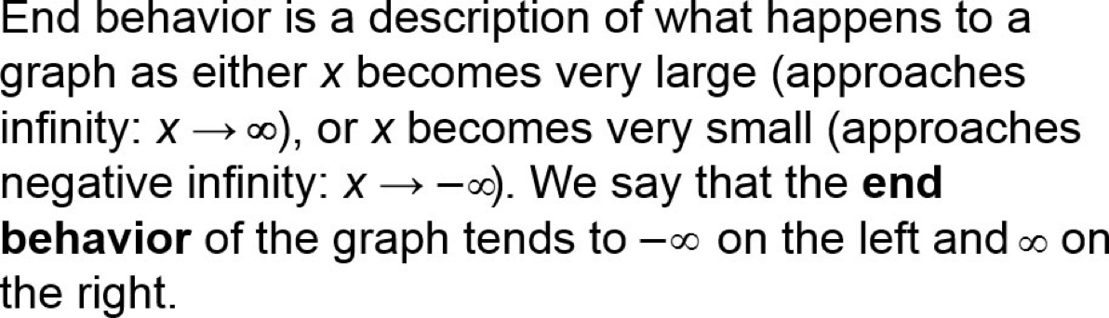

The end behavior depends on two things: degree of the polynomial (even or odd) and the leading coefficient (positive or negative).

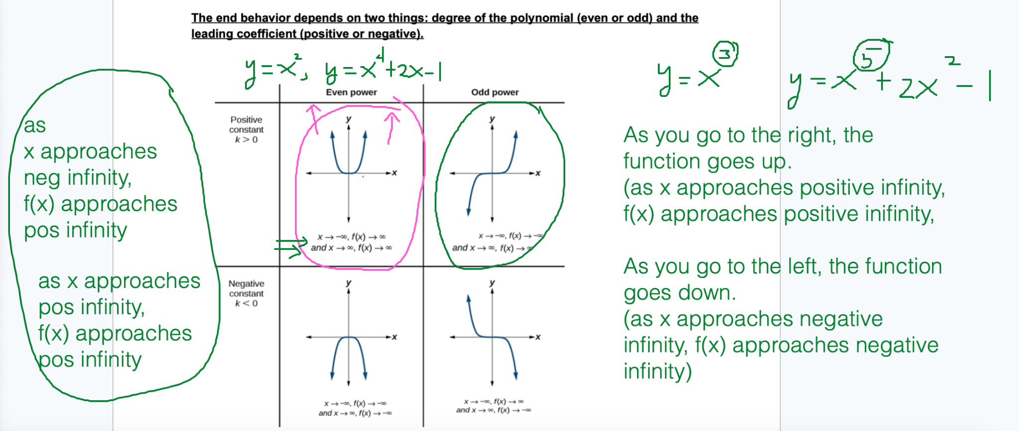

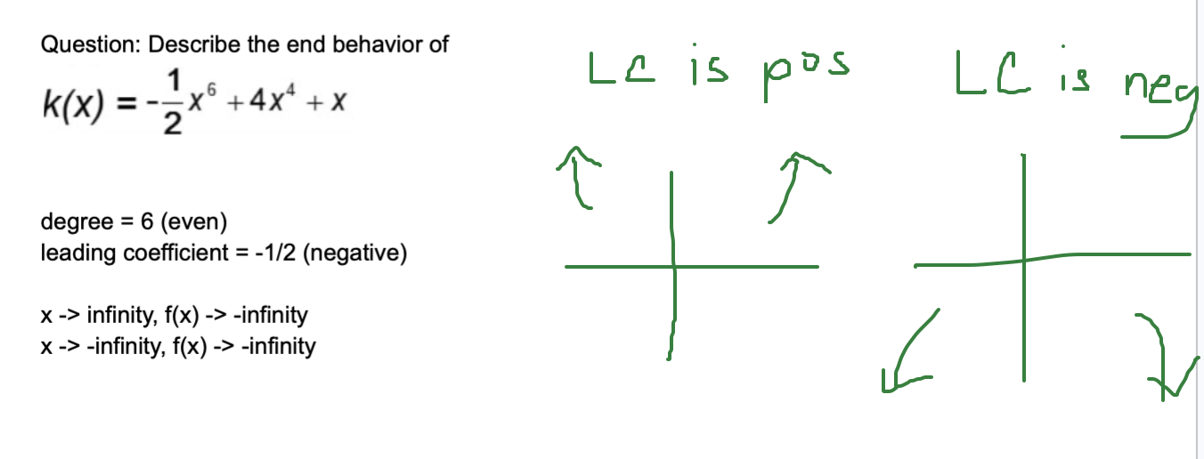

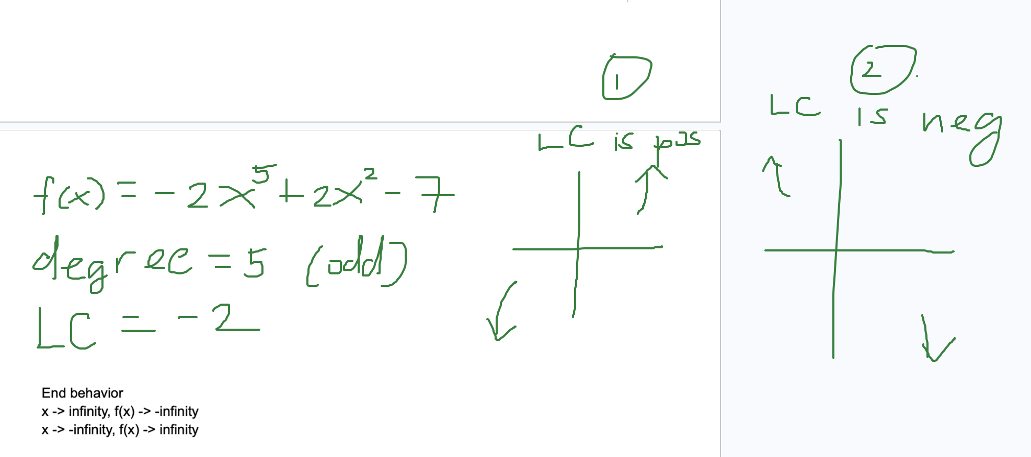

Families of Functions (Parent Functions)

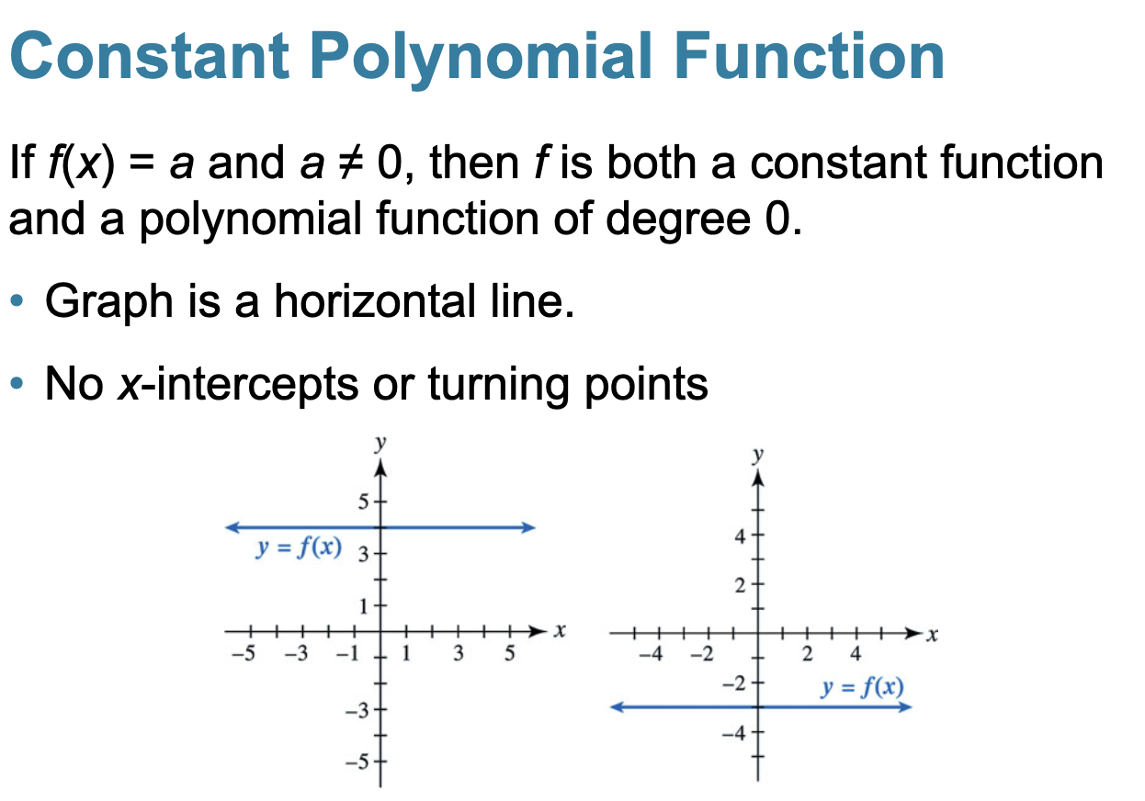
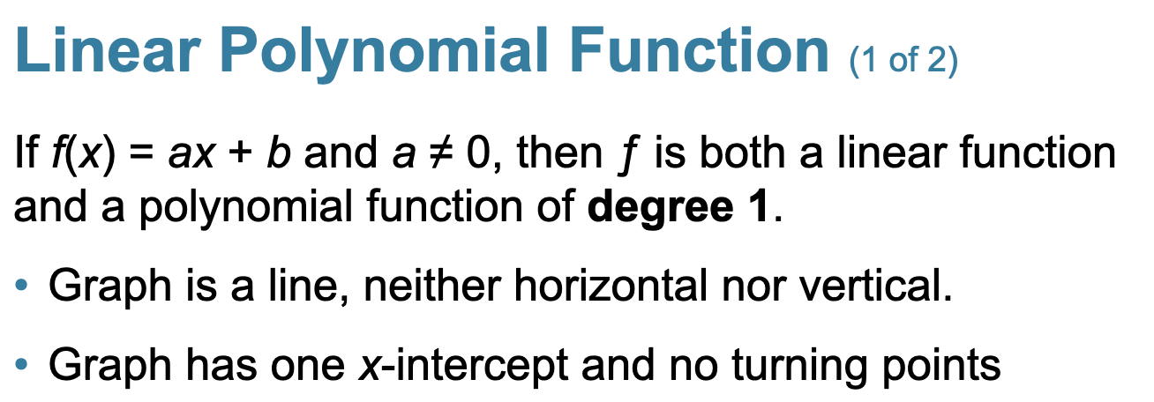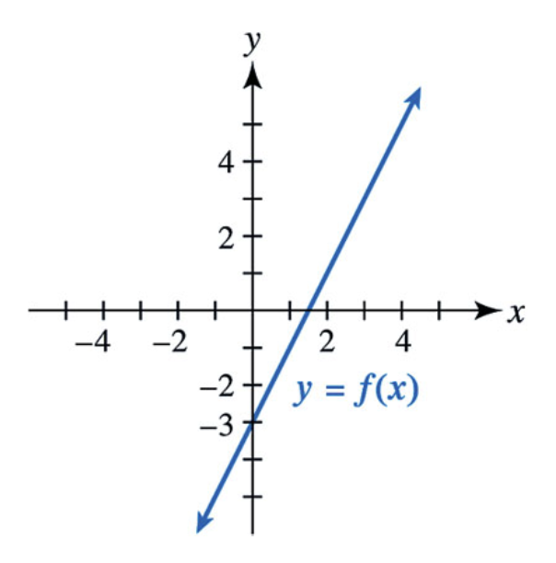

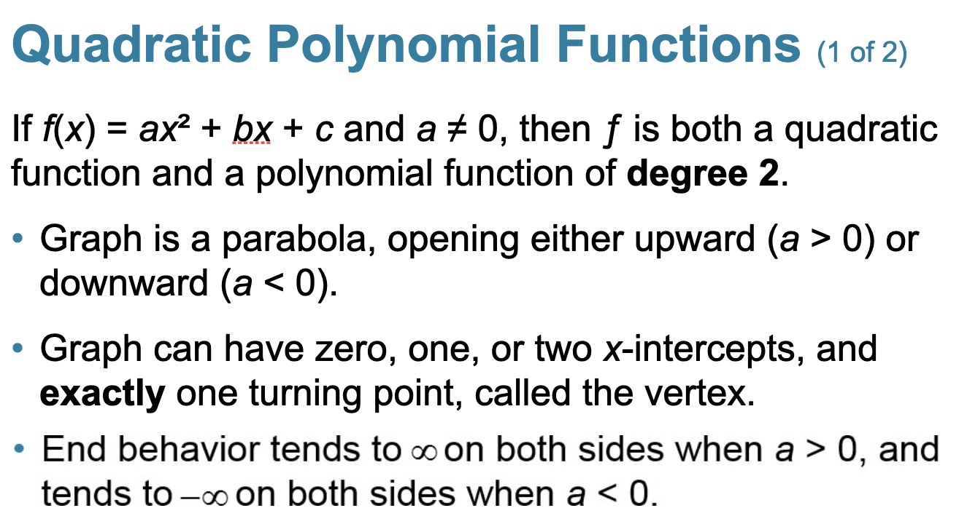
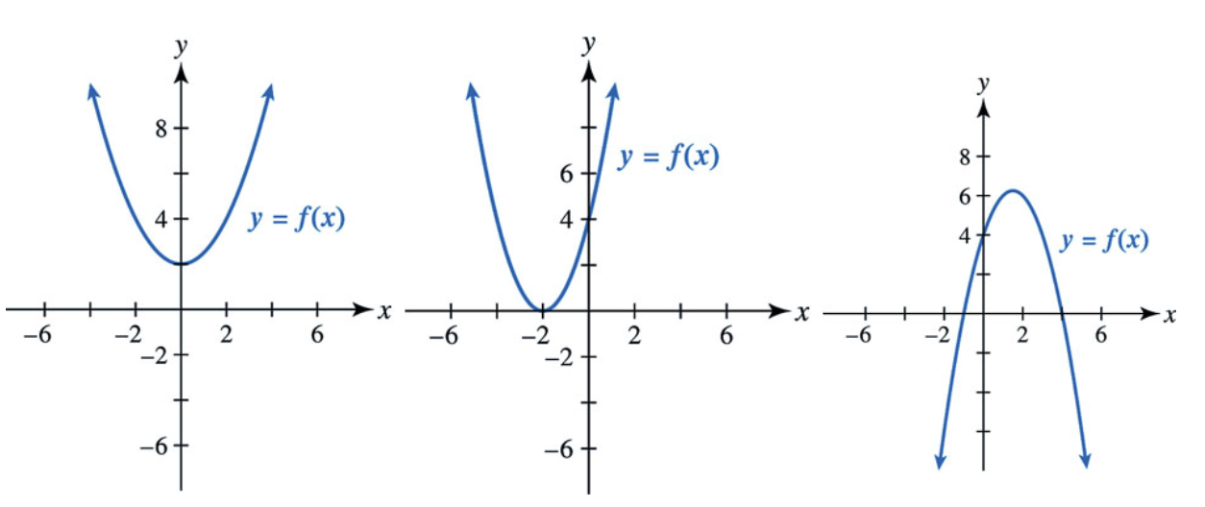
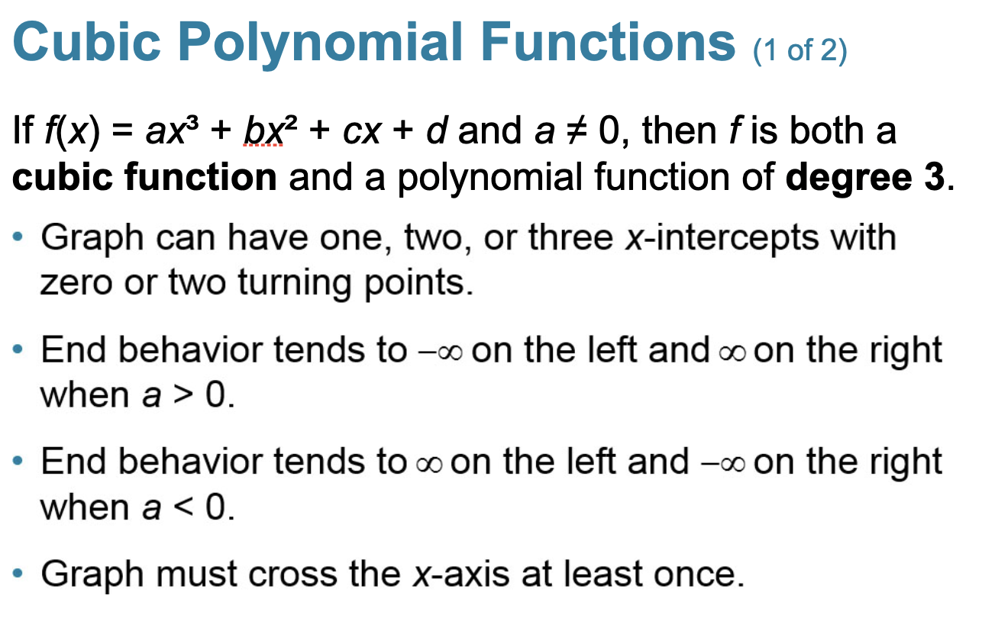

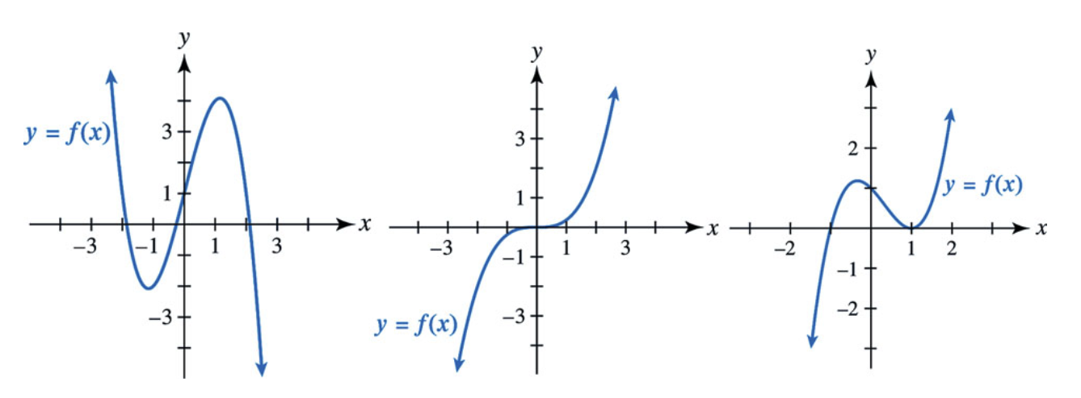

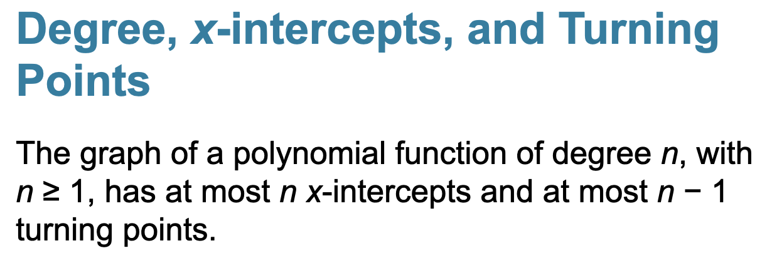

Question: What can we say about the maximum number of possible zeros and turning points for this function?



n = degree = 6
maximum number of turning points = 6 - 1 = 5 (there could be 5 turning points, or less)
maximum number of intercepts = 6 (there could be n x-intercepts, or less)
to be sure, we need to graph k(x).

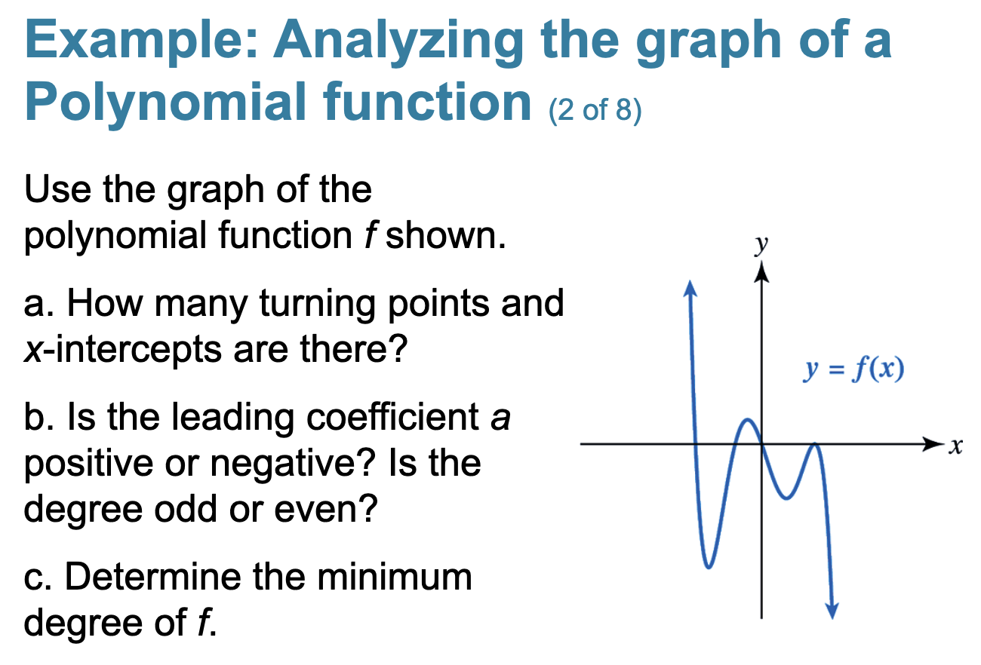

a)
number of turning points = 4
number of x-intercepts = 4
b)
degree is odd
leading coefficient negative
c)
minimum degree is 5 (it could be 7, 9, 11, 13, 15, ....)

